Planning Document

Client Requirements

The client would like for us to develop a database that can later be used as a source of info for the mobile and web apps. This database will contain reference materials for students. It will hold articles on three subjects: art, mathematics and technology. Each subject’s articles can contain biographies of key people, as well as articles on the major art objects, events and important notions.

This database may be accessed by administrators, tutors and students, so it will need various access levels;

* Students should be able to:
  + Browse articles by category
  + Browse articles by keyword in title
* Tutors should be able to:
  + Add or modify articles
* Administrators should be able to:
  + Add, modify or remove articles

Possible Solutions

* Django + SQL
* Django + Mongo
* SQL

Chosen Solution

SQL

Timeline

* Iteration 1 = 21/02/2019
* Iteration 2 = 26/02/2019
* Iteration 3 = 27/02/2019
* Iteration 4 = 28/02/2019

Iterations

* Iteration 1: Developing System Design document
  + Analyse the data and create Solution Design document outlining Architecture, Database Model, User Access and UX Design.
  + For each part of the Solution Design document, provide reasons of selecting technologies or choosing specific design.
* Iteration 2: Developing the Database
  + Create the database in the approved database management system.
  + Follow the approved database model to create the appropriate database structure.
  + Enter the test data provided.
* Iteration 3: Developing Database Queries
  + Create and test the appropriate queries as per client requirements.
    - Browse articles by category
    - Browse articles by keyword (in title)
    - Remove articles
    - Add articles
    - Modify articles
* Iteration 4: User Access Implementation Suggestions
  + Create suggestions on implementing the user access in the approved DBMS.

Kanban Board / Trello

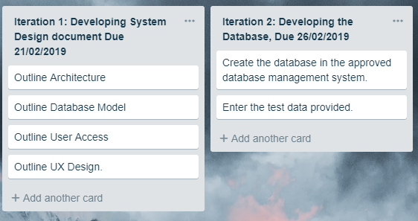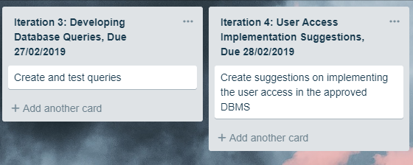

Client Feedback

Client gave the all clear, no changes needed.

Changes to Planning Document:

none